4.9 Exercise 1 - addition polymers

- Draw two repeating units of the polymer produced by the following alkenes:

- propene
- but-1-ene
- but-2-ene
- phenylethene
- tetrafluoroethene

- Name the following polymers and draw the monomer from which the polymer is made:

a)
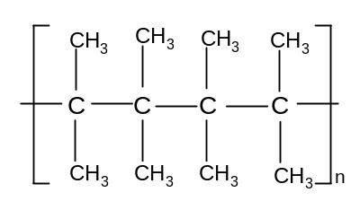

b)
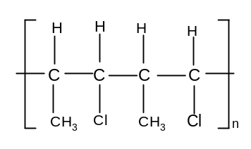

c)
